MEDIA ADVISORY
[Month] [Day], 2018
CONTACTS:
Marsha McDevitt-Stredney
Director of Marketing & Communications
State Library of Ohio
614-644-6875
marshams@msn.com

[Library/Institution Contact Name]
[Title]
[Library/Institution]
[Phone]
[Email]

Ohio Digital Network Brings the Buckeye State to DPLA

[City], Ohio: The [name of library/institution] and State Library of Ohio are pleased to announce that over 50,000 new materials from Ohio Digital Network are now discoverable in Digital Public Library of America (DPLA). Led by the State Library of Ohio and in partnership with Ohio Library and Information Network (OhioLINK), Ohio Public Library Information Network (OPLIN), and Ohio History Connection, the Ohio Digital Network builds on strong digital collection efforts across the state including [name of library/institution], Ohio Memory, and the Ohio Digitization Hubs project. [Name of library/institution] is one of the eleven Ohio libraries and cultural institutions members with collections in the initial launch of the Ohio Digital Network. As a part of DPLA, students and teachers, researchers, and history buffs can now explore all of these rich collections from across the state in one place alongside millions of resources from the growing DPLA network of partners.

“The State Library of Ohio is very proud to have led the Ohio Digital Network to this important point. We are very appreciative of the tremendous amount of work done by the many dedicated people in our partner institutions across the state,” expressed State Librarian Beverly Cain. “We look forward to working with them, and with our partners at DPLA, to continue developing Ohio's contributions to this culturally and historically significant collection of resources.”

The collections shared by members of the Ohio Digital Network represent stories that are both unique to Ohioans and part of our shared national story. Materials such as [Insert example from library/institution], wartime propaganda posters and oral histories about the May 4, 1970 Kent State shooting shed light on turning point moments in twentieth century history. Collections on Latino-American experiences in rural Knox County and on Ohio’s LGBT communities represent the lives, work, and relationships of local Ohioans, and ensure that the stories, voices, and experiences of these communities are captured as part of our national heritage. Ohio Digital Network also brings unique materials for gaming (old school, that is) and ornithology enthusiasts too—the history of chess and checkers collection and John James Audubon’s beautiful bird illustrations are not to be missed.

[Insert quote from library/institution spokesperson]
Preview highlights from these collections below or dive right in to explore Ohio’s collections!
[Note: URLs for links to featured items may change at launch]

[Insert brief description and image to highlight an example from library/institution]

The Public Library of Cincinnati and Hamilton County’s World War II poster collection joins a rich body of wartime posters in DPLA. One of the strengths of this collection is the collection of international posters, like this poster designed to recruit women for factory work. The poster was published in London during World War II.
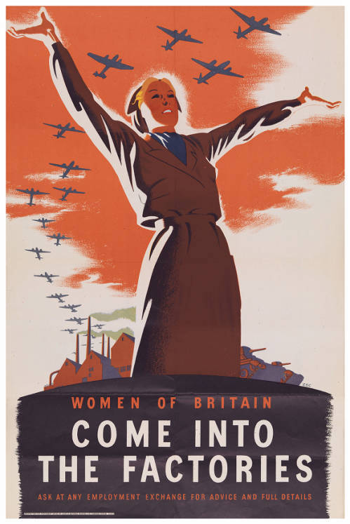
http://digital.cincinnatilibrary.org/digital/collection/p16998coll4/id/7/rec/10

On May 4, 1970, members of the Ohio National Guard opened fire on unarmed college students at Kent State University protesting the Vietnam War, killing four and injuring nine. The Kent State Shootings Oral History collection features over 125 interviews with former students, professors, law enforcement officers, local residents, and others about the experience of and impact of the shootings. Randy Gardner, a student at Kent State and eyewitness to the shootings, recalls his sense of shock as the shooting began:

“They got to the top of that rise, and they just kind of in unison turned around and just started shooting. And it was just—it was like you never gave thought to what's in their guns. Did they really have bullets? We didn't know. I don't think we gave it that much thought. I don't know why we didn't. But it was like disbelief that they were shooting—the shock, everything, you know. But when somebody's pointing a rifle at you and shooting, it's no time to ask questions.” https://omeka.library.kent.edu/special-collections/items/show/1679

Shared in partnership with Ohio History Connection, the Gay Ohio History Initiative collection documents organizing and activism within Ohio’s gay and lesbian communities during the 1980s and 1990s. In this photograph, members of the Stonewall Union Columbus chapter participate in the National March on Washington for Lesbian and Gay Rights in 1987.
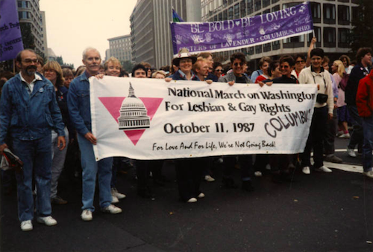
http://www.ohiomemory.org/cdm/singleitem/collection/p267401coll30/id/39/rec/62

Kenyon College’s Latinos in Rural America (LiRA) collection captures the stories of Latino-American residents of Knox County, Ohio. Through oral history interviews, photographs, and a bilingual exhibit, the project documents the lives, aspirations, and cultural identities of Latino Americans from different stages of life and socioeconomic backgrounds. José Ávalos, pictured here in his restaurant in Mount Vernon, Ohio, emigrated from Mexico and discusses his efforts to ensure that his children feel connected to their Mexican heritage.

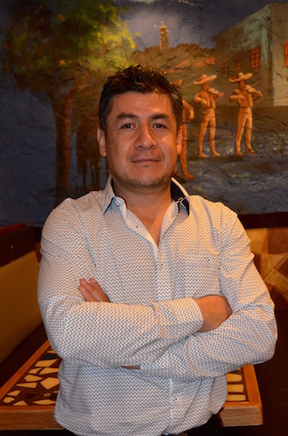
http://digital.kenyon.edu/lkca_images/17/
http://digital.kenyon.edu/cgi/viewcontent.cgi?article=1012&context=lkca_audio_video

For the game-lovers and strategists among us, check out Cleveland Public Library’s collection on the history of chess and checkers, which includes books dating to the sixteenth century, portraits of champion players, manuscripts, and more. In this photograph, Cuban chess prodigy José Raúl Capablanca plays forty games of chess simultaneously as part of an exhibition at the Manhattan Chess Club in 1922. His opponent at this board was 14-year-old David Warburgh of the Stuyvesant High School Chess Club.
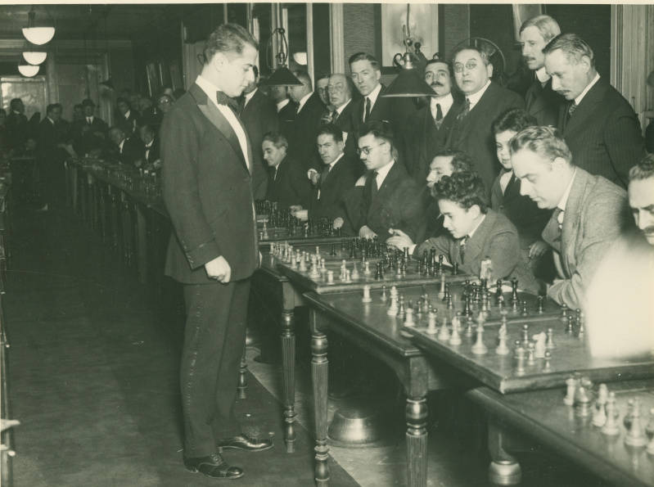
https://cdm16014.contentdm.oclc.org/digital/collection/p4014coll20/id/6/rec/1

Finally, ornithologists and nature art and illustration fans will want to explore the John James Audubon Birds of America collection from the Public Library of Cincinnati and Hamilton County. The collection includes 435 plates from Audubon’s landmark publication, The Birds of America, which was published between 1827 and 1838, and documents the bird species of North America, including the Carolina Turtle Dove.

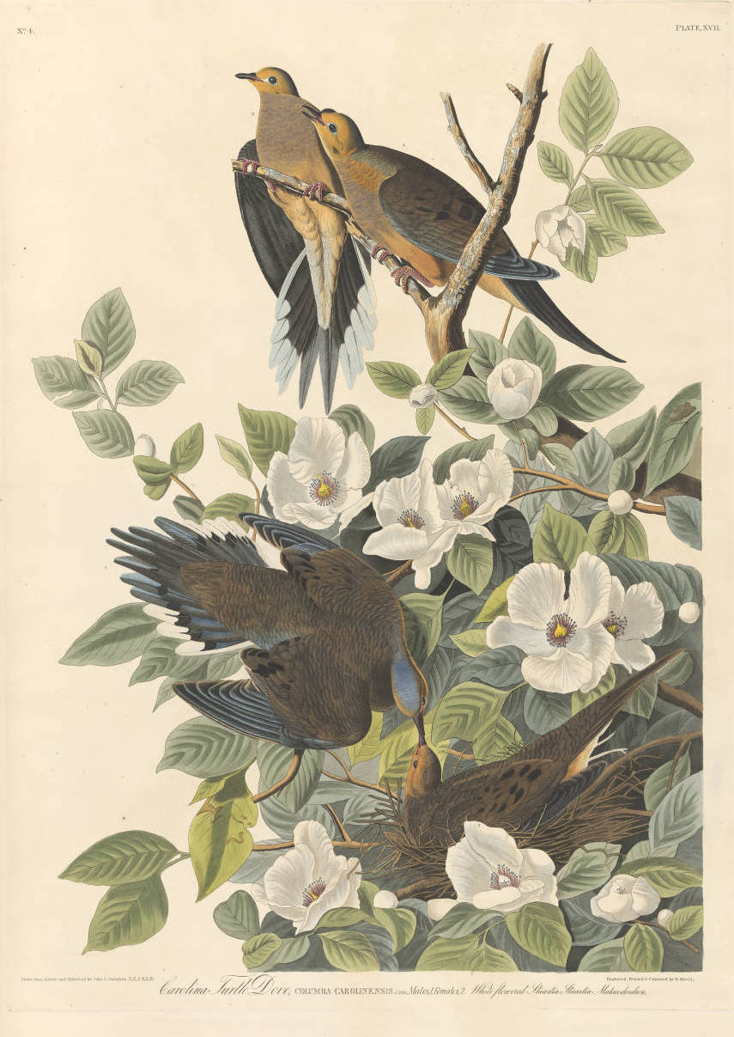
https://cdm16998.contentdm.oclc.org/digital/collection/p16998coll33/id/18/rec/1
The Ohio Digital Network will continue to work with libraries, archives, and cultural heritage organizations to grow Ohio content in DPLA. Additional collections from the original eleven participating institutions as well as collections from other institutions will be added over time.
The work of Ohio Digital Network is generously supported in part by LSTA funds awarded to the State Library by the Institute of Museum and Library Services and the Ohio Public Library Network (OPLIN).
[Insert information about library/institution]
DPLA connects people to the riches held within America’s libraries, archives, museums, and other cultural heritage institutions. All of the materials found through DPLA—photographs, books, maps, news footage, oral histories, personal letters, museum objects, artwork, government documents, and so much more—are free and immediately available in digital format. The cultural institutions participating in DPLA represent the richness and diversity of America itself, from the smallest local history museum to our nation’s largest cultural institutions. The core work includes bringing new collections and partners into DPLA, building our technology, and managing projects that further our mission through curation, education, and community building. DPLA launched in April 2013 as the result of a multiyear grassroots planning initiative involving thousands of volunteers dedicated to the vision of building a national digital library for all.

Established in 1817, the State Library of Ohio is a state agency that serves state government and all types of libraries. The vision for the State Library is a Smarter Ohio where every Ohioan can access the necessary resources to be engaged citizens, excel at their jobs, participate in the workforce, and pursue their passions and interests. The State Library of Ohio ensures a smarter Ohio by managing the delivery of services through three channels: Directly, by building and managing quality collections and providing hands-on service to state government; Cooperatively, through collaborative efforts and information sharing networks within the library community; Virtually, through online and on-the-go access to expert assistance, digitized resources, and a vast selection of electronic materials.

The Ohio Public Library Information Network (OPLIN) provides broadband Internet connections and related information services to Ohio public libraries. Their primary mission is to ensure that all Ohio residents have fast, free public Internet access through the 251 independent local public library systems in Ohio, as well as the use of high-quality research databases not freely available on the World Wide Web. Though the eventual consumers of their services are often members of the general public, their actual customers are in fact limited to the public library systems of Ohio.

Established in 1992, the Ohio Library and Information Network (OhioLINK) is Ohio’s statewide academic library consortium and serves more than 600,000 end users, with 121 libraries as full members. These libraries are distributed among 93 different Ohio colleges and universities. OhioLINK membership includes the State Library of Ohio, 16 public university libraries, 51 independent college libraries, 23 two-year college libraries, 16 regional campus libraries, 8 law school libraries and 5 medical school libraries. A member of the Ohio Technology Consortium of the Ohio Department of Higher Education, OhioLINK provides a competitive advantage for Ohio’s higher education community by cooperatively and cost-effectively acquiring, providing access to and preserving an expanding array of print and digital resources, and by centrally hosting digital content.

The Ohio History Connection is a statewide history organization with the mission to spark discovery of Ohio’s stories. As a nonprofit organization chartered in 1885, the Ohio History Connection carries out history services for Ohio and its citizens focused on preserving and sharing the state’s history. This includes housing the state historic preservation office, the official state archives, local history office and managing more than 50 sites and museums across Ohio.

Established in 2000, Ohio Memory is the collaborative statewide digital library program of the Ohio History Connection and the State Library of Ohio. On this free website, you can explore digital content from over 360 cultural heritage institutions representing all 88 of Ohio’s counties! Ohio Memory contains over 700,000 digital images from a variety of primary source image types.

###

